Khadi Valieva

Dr. Sengupta

CSC 408

28 October 2024

Classwork 11

Problem 1

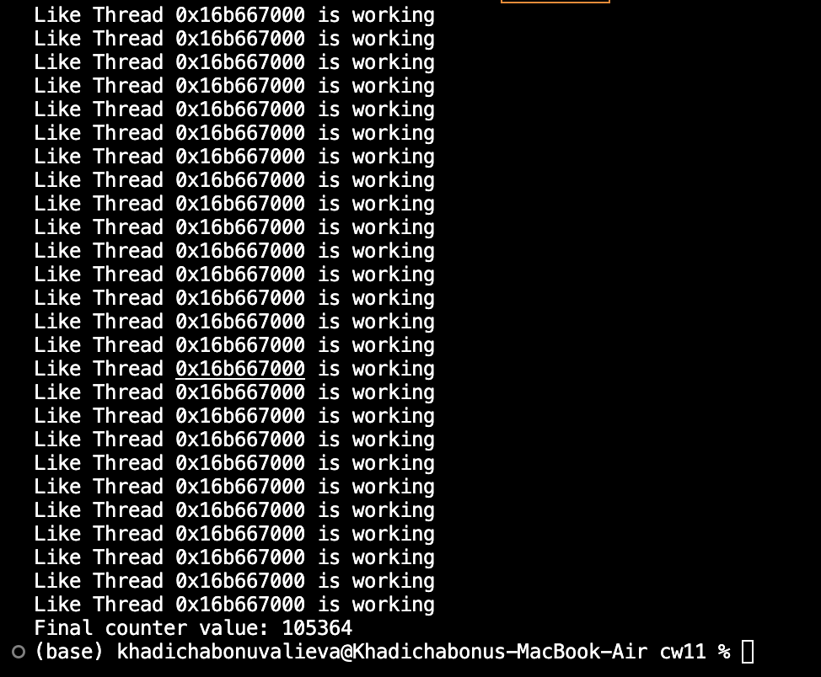

Problem 2

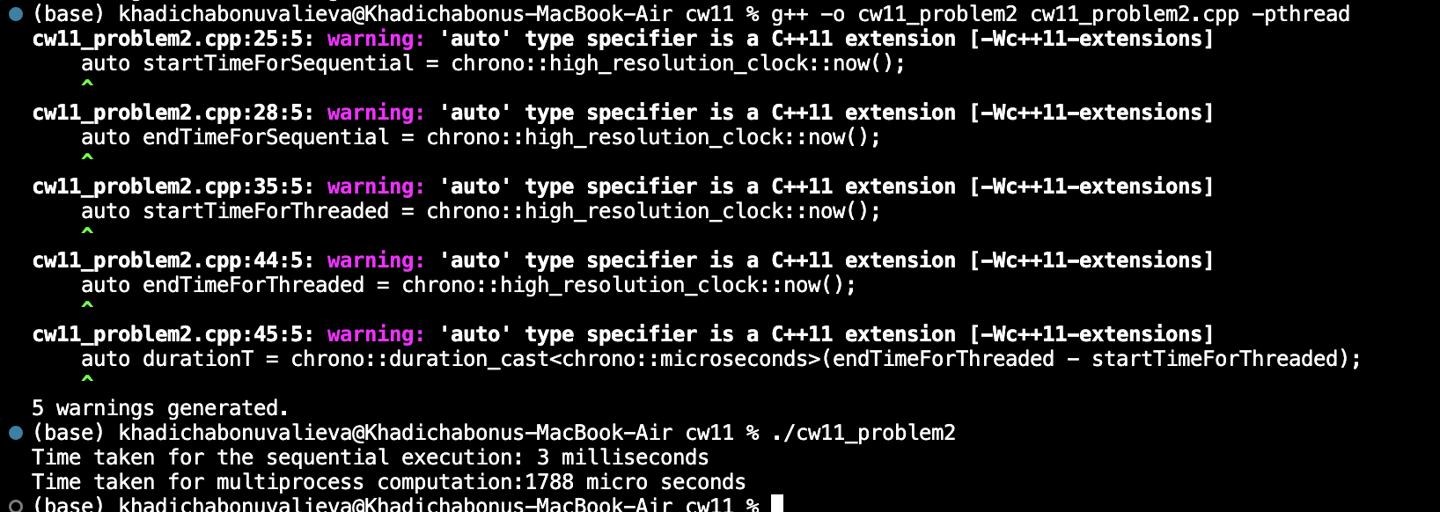

Problem 3

